

NIRMA UNIVERSITY

INSTITUTE OF TECHNOLOGY

**Mini Project Report**

**On**

**“TIC TAC TOE GAME”**

**B. Tech CSE**

**(2CS101 Computer Programming)**

Submitted by: -

Diksha Sharma 21cek084

**INDEX**

1. Title of the project…………………………….03
2. Objective……………………………………...03
3. Introduction…………………………………...03
4. Methodology
5. Flowchart…………………………………04
6. Features of the C language used………05-08
7. Output……………………………………...08-09

**TITLE OF THE PROJECT:** Tic tac toe game

**OBJECTIVE:**

The objective of our mini project is to make a tic tac toe game.

**INTRODUCTION:**

Tic tac toe game is very popular and is fairly simple in itself. It is actually a two-player game. In this game, there is a board with 3*3 squares. The goal of tic tac toe is to be one of the players to get 3 same symbols in a row-horizontally, vertically or diagonally on a 3*3 grid.

The game is played as follows:

1. Firstly, the player can choose any of the two symbols between “X” and “O’. If the first player chooses “X” then the second player has to play with “O” and vice-versa.
2. A player marks any one of the 9 boxes of the 3*3 square board with his/her symbol (may be “X” or “O”) at one time and his/her aim is to create a straight line horizontally or vertically or diagonally with two intentions:
   * + Create a straight line before his/her opponent to win the game.
     + Restrict his/her opponent from creating a straight line first.
3. In case, logically no one is able to create a straight line with his own symbol, the game results in a tie.
4. Here, there are 3 possible results – a player wins, his/her opponent wins or the game results in a tie.

**METHODOLOGY:**

* **Flowchart**

START

Declare Array

Creating board

Player 1-X

Player 2- O

Player marks the board with X or O

Check if anyone won

True

While i==-1

False

Final board pattern created

i=0

i=1

Draw match

Player 1 or 2 won the match

STOP

* **Features of the C used:**

1. 1D array of character type: - It holds all the elements (the numbers) on the board.

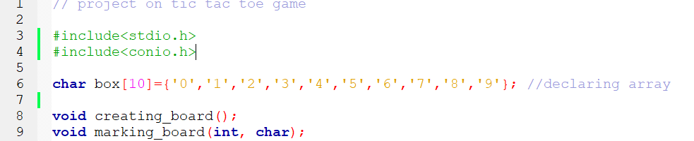

2. Creating Functions

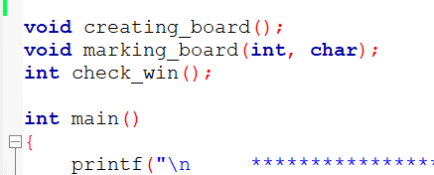

1. creating_board (void): - It is used to create the 3*3 board.

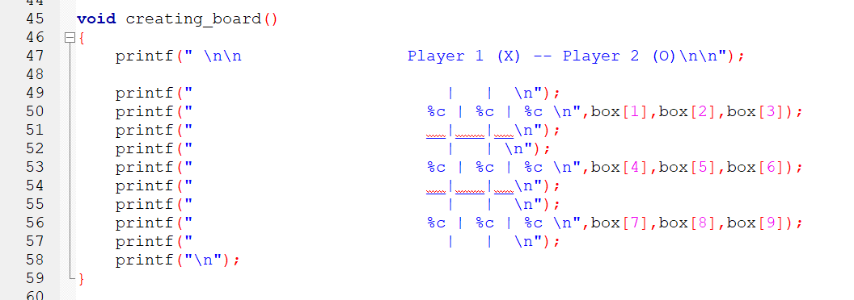

1. marking_board (int, char): - It is used to mark the various positions on the board by “X” or “O”.

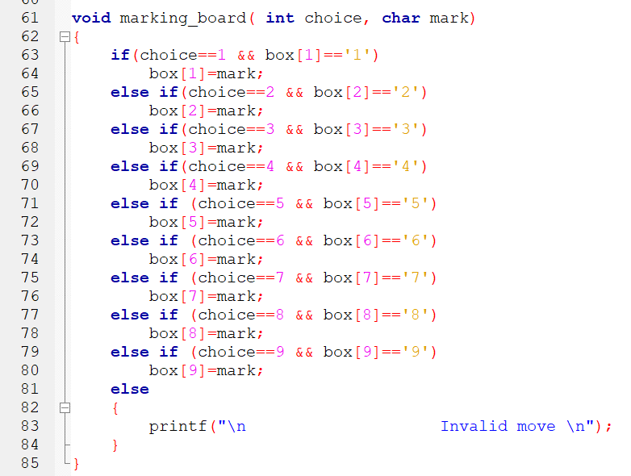

1. check_win(int) :- This function is used for checking the winner. If the result is 1, it means that one of the two players won and if the result is 0 then the match is tie.

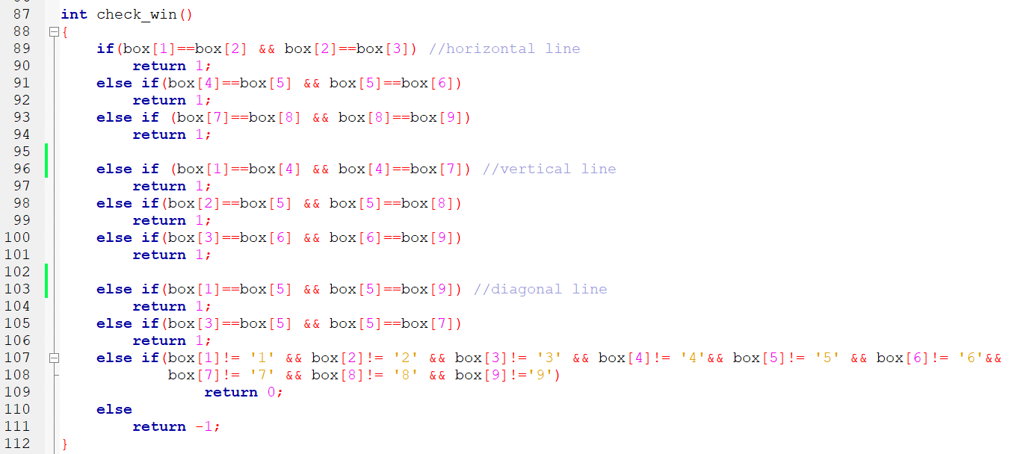

3. Do. While loop

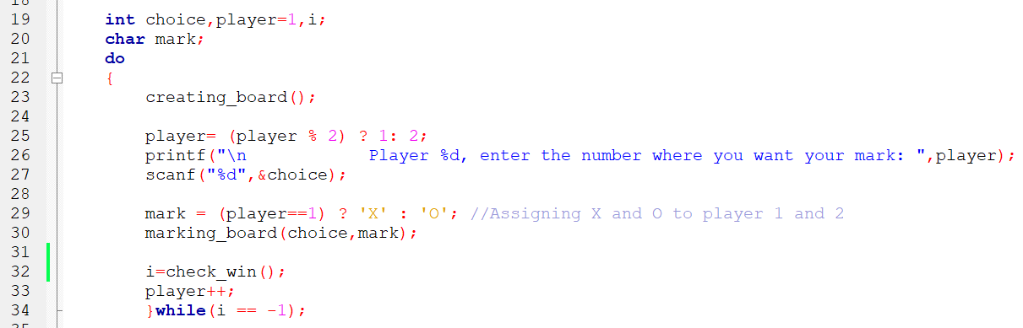

4. If…else if…else statements

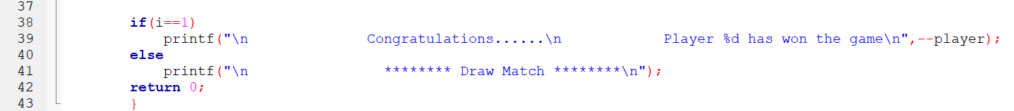

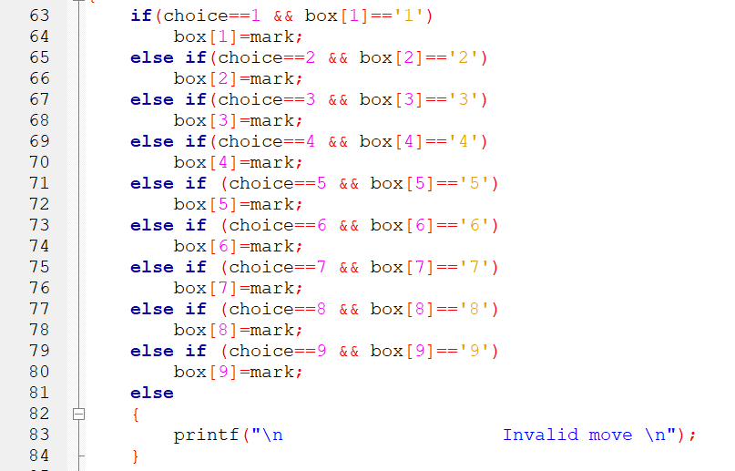

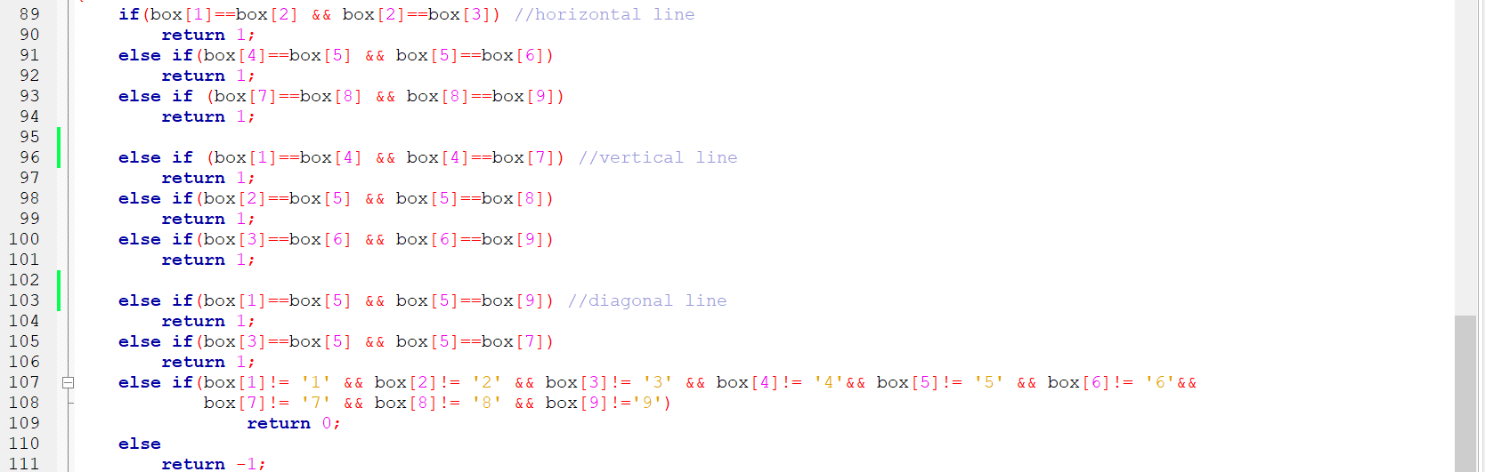

**Output: -**

